**Lab Report**

Title: Best Walking Route to go Flyfishing

Notice: Dr. Bryan Runck

Author: Ethan Bott

Date: 11/2/22

**Project Repository:**[*https://github.com/swimbott/GIS5571/tree/main/Lab2*](https://github.com/swimbott/GIS5571/tree/main/Lab2)

**Time Spent:** 30

**Abstract**

An optimal route will be created to help Dory most efficiently navigate to her fly fishing route with her preferences influencing how the route will be modeled. Identifying and bringing in the right data sources is the first step. Then formatting it into the correct study extent and manipulating it correctly to be used in the model is next. This will involve clipping and masking the data to the study extent so my analysis won’t be covering the entire state. Next the data layers will be classified to a common range of 1-10 and then a series of cost surfaces will be created as the basis for the mode. Using these series of models with her different preferences weighed, an optimal route will be created that will from her home to her fly fishing spot.

**Problem Statement**

Dory lives almost 10 miles from Whitewater State Park (Figure 1) where she likes to fly fish every day in the spring. She loves to hike to her “spot”, but does not like walking over muddy farm fields, crossing “big” rivers, but will if it’s a small ephemeral stream, and lastly she wants to take a gradual route there and not have to go over cliffs and such.

*Figure 1. Dory’s house is in the upper left and she is trying to find the best route to her fly-fishing spot in Whitewater State Park.*

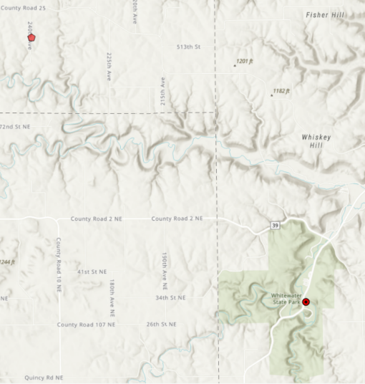

There are a lot of farm fields around her home along with steep banks leading to several rivers which are barriers to her route. However, there are a series of bridges and roads that have crossed the rivers which as a result, has made the steep cliffs more gradual. There are numerous ephemeral streams that appear to be barriers, but Dory is confident crossing them in her waders if they are shallow enough.

*Table 1. Requirements for the project*

|  |  |  |  |  |  |  |
| --- | --- | --- | --- | --- | --- | --- |
| **#** | **Requirement** | **Defined As** | **(Spatial) Data** | **Attribute Data** | **Dataset** | **Preparation** |
| 1 | MN NLCD 2019 | Raw input dataset of landcover | Raster | Landcover type | [Mn GeoSpatial Commons](https://gisdata.mn.gov/dataset/biota-landcover-nlcd-mn-2019) | Extract by mask to study extent |
| 2 | MN Streams w/ Strahler stream order | Raw input dataset of streams in MN | Vector lines | Stream Order and length | [Mn GeoSpatial Commons](https://gisdata.mn.gov/dataset/water-strahler-stream-order) | Clip to study extent |
| 3 | NLCD 2019 Impervious Surfaces | Raw input dataset of impervious surfaces in MN | Raster | Impervious Surface type | [Mn GeoSpatial Commons](https://gisdata.mn.gov/dataset/biota-landcover-nlcd-mn-2019) | Extract by mask to study extent |
| 4 | MN DEM 30m | Raw input dataset of Digital Elevation Model of MN | Raster | Elevation | [Mn GeoSpatial Commons](https://gisdata.mn.gov/dataset/elev-30m-digital-elevation-model) | Extract by mask to study extent |
| 5 | MN County boundaries | All county boundaries of MN | Vector polygons | County Boundary | [Mn GeoSpatial Commons](https://gisdata.mn.gov/dataset/bdry-counties-in-minnesota) | Clip to study extent |

**Input Data**

There are four major inputs into this model that will determine the optimal route that Dory will take. They all need to be in raster format for the model to successfully work. Three of the four datasets come in raster format. The first being land cover which comes from the National Land Cover Database (NLCD) as a raster. This dataset identifies landcover from farm fields to urban areas to grassland areas. The second raster input is impervious surfaces which again is from the NLCD. This dataset contains information on the type of road from primary or secondary road. The final raster dataset that will be brought in, is the 30m DEM of MN which has been derived from the USGS. This raster dataset will help calculate slope which will be needed in the model.

The final input into the model are the streams data which includes the order of the stream which will help determine if a stream is small enough to cross with waders. This dataset will have to be converted to a raster so that the analysis will work properly. And then finally a country boundaries dataset was imported to help define the study extent.

*Table 2. Data purpose and source.*

|  |  |  |  |
| --- | --- | --- | --- |
| **#** | **Title** | **Purpose in Analysis** | **Link to Source** |
| 1 | MN NLCD 2019 | To weight farm fields as undesirable for routing analysis | [Mn GeoSpatial Commons](https://gisdata.mn.gov/dataset/biota-landcover-nlcd-mn-2019) |
| 2 | MN Streams w/ Strahler stream order | To weight streams as undesirable for routing analysis | [Mn GeoSpatial Commons](https://gisdata.mn.gov/dataset/water-strahler-stream-order) |
| 3 | NLCD 2019 Impervious Surfaces | To weight roads and bridges as desirable for routing analysis | [Mn GeoSpatial Commons](https://gisdata.mn.gov/dataset/biota-landcover-nlcd-mn-2019) |
| 4 | MN DEM 30m | To weight slope for routing analysis | [Mn GeoSpatial Commons](https://gisdata.mn.gov/dataset/elev-30m-digital-elevation-model) |
| 5 | MN County boundaries | To define study area | [Mn GeoSpatial Commons](https://gisdata.mn.gov/dataset/bdry-counties-in-minnesota) |

**Methods**

After identifying all relevant data, the first step was creating ETL pipelines to get the data into an ArcPro notebook. All the data came from the MN Geospatial commons, so a similar pipeline was able to be created to get the data in.

Once the data was in, the first step was to create the study extent. Knowing the Dory’s place was in Wabasha County, her final destination was in Winona County, and her potential route could have traveled through Olmstead County, the outside of the county boundaries of those three were used as the study extent. Using the feature class to feature class tool: Winona, Olmstead and Wabasha County were selected as their own individual feature class. Then using the merge tool, they were merged into one single feature class. And finally with the dissolve tool, they were “merged” into one feature class with just their outside boundaries as the feature class. This is now the study extent for the rest of the project.

Next, an extract by mask function was run on the impervious road data to have data only within the study extent. The reclassify function was fun where unclassified values were given a value of 10, primary, secondary and tertiary roads were given a value of 1, non-roads were given a value of 2, LCMAP impervious roads were given a value of 3 and wind turbines were given a value of 7 (Figure 2).

Note: Figures of the tools run in ArcPro were used to help illustrate how the tool worked and what inputs were used, rather then an image of a long line of code.

*Figure 2. Reclassification for the impervious roads within the study extent.*

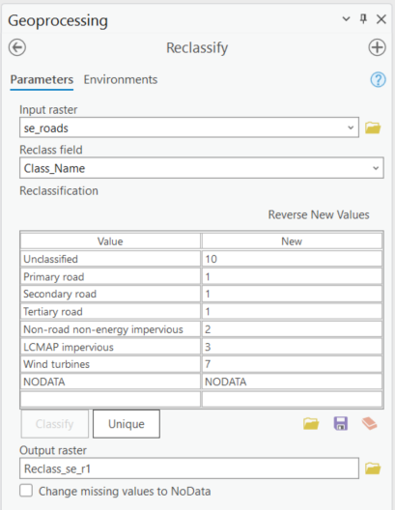

After getting the DEM into an ArcPro notebook using and ETL data pipeline, the extract by mask tool was used to create the study extent of the roads dataset. The acrpy Slope tool was then applied to the study extent of the DEM to calculate slope. Percent rise was requested to be the output rather then degree of slope change. The reclassification arcpy tool was used to reclassify slope (Figure 3) where low percent rise slopes were reclassified with a low value, values around 8% were still optimal and just about anything above 15% rise was given a highly unsuitable value from 8-10 (Friedman).

*Figure 3. Reclassification of slope within the study extent.*

Once the landcover data was brought in again through an ETL data pipeline, an extract by mask was done on the data to get clip it to the study extent. The reclassify tool (Figure 4) was run on it where unsuitable areas like water, farm fields, and wetlands were given a highly unsuitable value while more desirable walking surfaces like urban areas were given a lower suitable value.

*Figure 4. Reclassification of landcover within the study extent.*

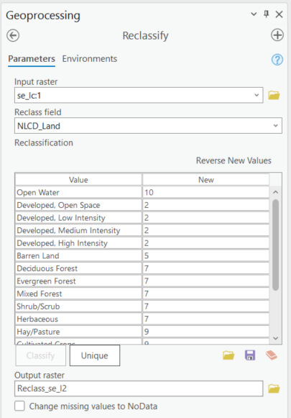

The final input layer of streams was again brought in through an ETL data pipeline. However this was a vector dataset that will eventually have to be converted to a raster for the model to run correctly. A clip was performed on the stream data to clip it to the study extent. Then a feature to raster tool was run so that it was a raster dataset. Then the reclassify tool was run (Figure 5) where streams with a Strahler order of 1 or 2 were given a suitable value of 1 and 2 respectively. These streams are tiny and are easily crossable with waders. All other streams orders (3-8) were too large, especially during spring to cross with waders and were given highly unsuitable values of 8-10.

*Figure 5. Reclassification of streams within the study extent.*

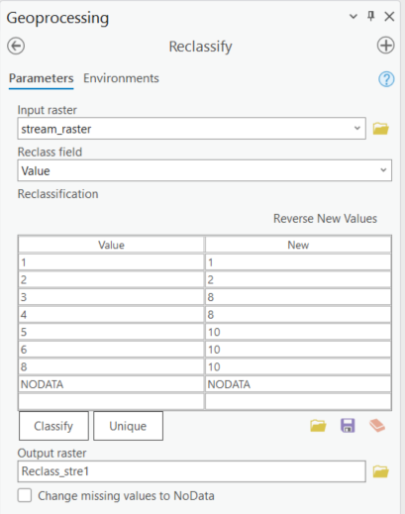

However, since there was just pixel values of streams, the rest of the study extent had to have some type of data as it currently was “no data”. A raster calculation (Figure 6) was run on the data where any values within the study extent that returned null, were given a value of 0 using a python script. Now every pixel in the study extent was accounted for and had a value. This was attempted in the ArcPro notebook, but it kept failing in the notebook and so this was run using the tools within ArcPro as seen below.

*Figure 6. Raster calculation to change null values to a data value.*

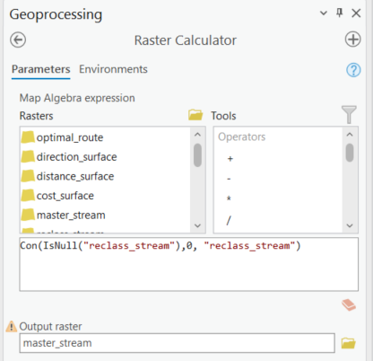

Now with four input raster datasets, they could then be inputted into the weighted overlay tool. Each of the four input layers were given an equal weight of 25% as each were just as important in my opinion of weighting the model (Figure 7). This created a Cost Surface Raster that will be used in the next step.

*Figure 7. Weighted overlay of the four input raster datasets (slope, streams, roads, landcover).*

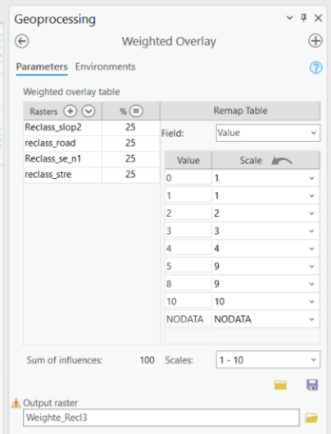

To do the next step, the start point or Dory’s house had to be brought in spatially to the project. With her known coordinates of her house, those were put into a csv table of lat and long. Then using the XY table to point tool (Figure 8), her coordinates were transformed from a series of numbers to points on a map. For her end location, coordinates were selected from a random spot on google maps around the parking lot that she is trying to get to. The same process of utilizing the XY table to point tool was again used to create a point.

*Figure 8. XY Table to point tool to get the coordinates into points of Dory’s start and end locations.*

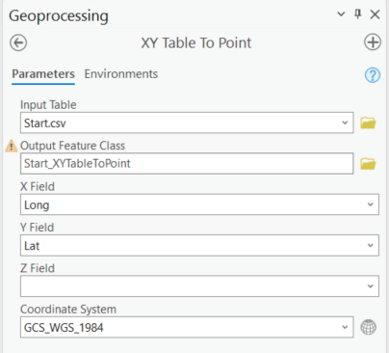

Now with both a cost surface raster and a starting point, the Cost distance tool was run to create both a distance and a direction raster from Dory’s start point. This process was note working in ArcPro Notebooks, but the exact same inputs were working in the toolbox through the ArcPro interface. The notebook was not outputting a direction raster which was needed for the final step.

Finally, with a distance and direction raster and Dory’s end point (her fly fishing spot), the cost path tool was run using those inputs to create the final optimal route from Dory’s home to her fly fishing spot.

*Figure 9. Data flow diagram.*

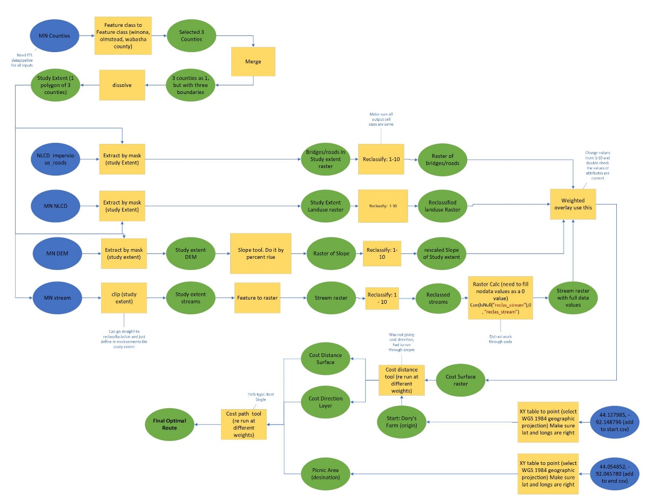

**Results**

There were several results that created the final optimal route. There were four input datasets that helped run the model. The first one being reclassified roads where roads were given a suitable value of 1 and everything else was given an unsuitable value (Figure 8). This was needed in the model as it would tell the model that roads were a good value to route Dory.

*Figure 10. Reclassified roads.*

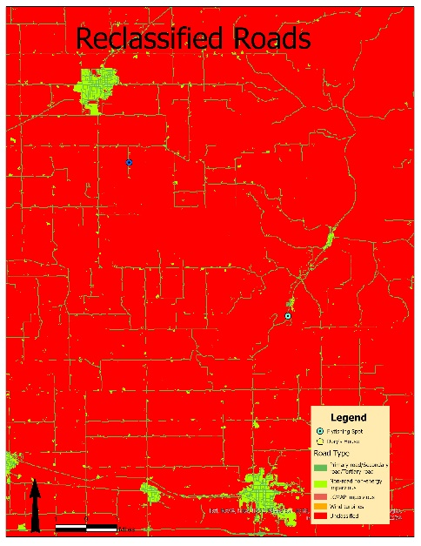

The next input result was of slope where flat areas were given a suitable value and steep areas were unsuitable. This would tell the model where Dory would prefer to walk and areas that she would tend to avoid.

*Figure 11. Reclassified Slope.*

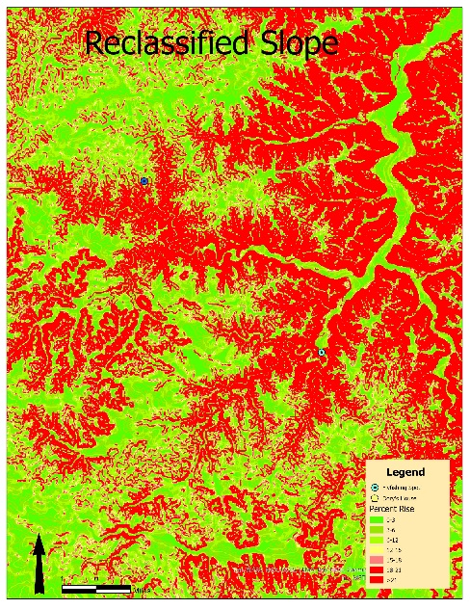

The third input’s result was of streams. Larger streams as defined by the Strahler Stream order were given an unsuitable value while smaller streams were given a suitable value with the knowledge that Dory could cross small streams with her waders.

*Figure 12. Reclassified streams.*

The final input is landcover whose resulting map shows areas that are unsuitable to Dory which are farm fields, wetlands, water, etc. Urban areas were given suitable values as that would be easier to walk through then on non-paved areas.

*Figure 13. Reclassified Landcover.*

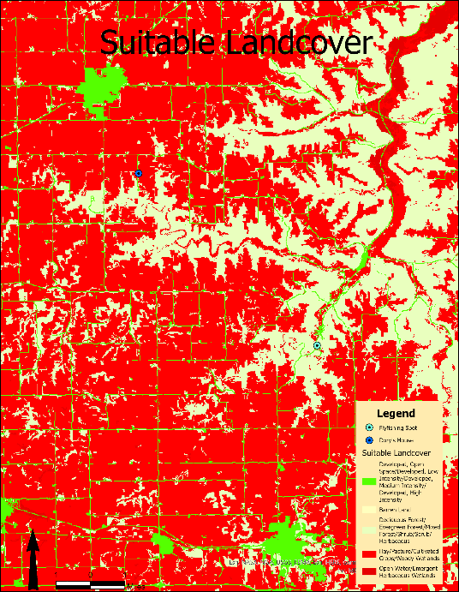

The resulting map of these four inputs was a cost surface that showed each pixels cost with traveling over that single pixel. Areas in orange and red were less suitable to walk on and areas in green are more suitable to walk over.

*Figure 14. Cost surface raster.*

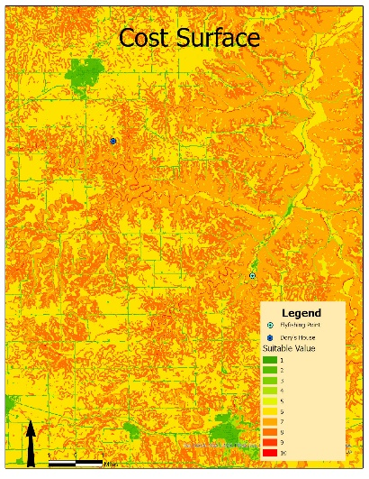

Then with the outputs from the cost distance tool, this create the final optimal route from Dory’s house to her favorite flyfishing spot.

*Figure 15. Optimal Route.*

**Results Verification**

There technically is no “right” answer as this is a model and there could be a thousand different ways to run the model. Based on my research and own biases, I believe this is the best route for Dory to take based off of what I know about her preferences. Using research about what streams she likely could or could not cross with waders helped inform my decision making about how to classify each stream. Additionally, research on what the optimal grade is to walk on helped inform how I classified slope.

I reclassified roads in general as highly suitable to walk on, much more then any other surface. If I were in Dory’s shoes, the resulting optimal path is what I would prefer as well. I would want to walk on roads for the most part and avoid having to bush whack for 10 miles to get to my destination.

**Discussion and Conclusion**

This was an enjoyable lab as it was awesome to have a final/optimal route and feel like I accomplished something in ArcPro. I really learned the value of a data diagram and how much time that saves to figure out all the steps ahead of time. Then when it comes time to write the code, I knew exactly what function to use.

I was really interested in using different ways of calculating the distance raster, but ultimately went with the tried and true workflow that is well documented. I had trouble at times running certain functions in the notebook, so I had to run them in ArcPro instead.

And finally in terms of the results, I was really expecting my final route to look like this as I knew I had valued roads as highly suitable for Dory to walk on. Just looking at the cost surface raster, one can visualize that the optimal path would be following the road network. But now Dory can have a nice easy and long walk to her favorite flyfishing spot thanks to this analysis!

**References:**

Creating a least cost surface

<https://desktop.arcgis.com/en/analytics/case-studies/cost-lesson-1-desktop-creating-a-cost-surface.htm>

Creating a least cost path

<https://desktop.arcgis.com/en/arcmap/10.3/tools/spatial-analyst-toolbox/creating-the-least-cost-path.htm>

Cost distance documentation

<https://pro.arcgis.com/en/pro-app/latest/tool-reference/spatial-analyst/cost-distance.htm>

Creating a value from no data in ArcGIS Pro

<https://support.esri.com/en/technical-article/000010059>

Merging features classes in arcpy

<https://community.esri.com/t5/python-questions/merging-features-in-feature-class-with-arcpy/m-p/466857#M36487>

MN landcover meta data

<https://resources.gisdata.mn.gov/pub/gdrs/data/pub/us_mn_state_dnr/biota_landcover_nlcd_mn_2019/metadata/metadata.html>

Modeling cost distance

<https://www.youtube.com/watch?v=0fhwaojCkAU&ab_channel=TheGeomatician>

What is the ideal slope

<https://inspectapedia.com/Stairs/Access_Ramp_Slope.php#:~:text=The%20desirable%20ramp%20slope%20standard,specifically%20for%20people%20with%20disabilities>.

Friedman, D. J. (n.d.). *Building access ramp slope or pitch requirementsrecommended access ramp Angle Slope & run length*. Building Access Ramp Slope or Pitch Requirements - Ramp Angles & Run Lengths Allowed. Retrieved October 26, 2022, from https://inspectapedia.com/Stairs/Access_Ramp_Slope.php#:~:text=The%20desirable%20ramp%20slope%20standard,specifically%20for%20people%20with%20disabilities

**Self-score**

|  |  |  |  |
| --- | --- | --- | --- |
| **Category** | **Description** | **Points Possible** | **Score** |
| **Structural Elements** | All elements of a lab report are included **(2 points each)**:  Title, Notice: Dr. Bryan Runck, Author, Project Repository, Date, Abstract, Problem Statement, Input Data w/ tables, Methods w/ Data, Flow Diagrams, Results, Results Verification, Discussion and Conclusion, References in common format, Self-score | 28 | **28** |
| **Clarity of Content** | Each element above is executed at a professional level so that someone can understand the goal, data, methods, results, and their validity and implications in a 5 minute reading at a cursory-level, and in a 30 minute meeting at a deep level **(12 points)**. There is a clear connection from data to results to discussion and conclusion **(12 points)**. | 24 | **24** |
| **Reproducibility** | Results are completely reproducible by someone with basic GIS training. There is no ambiguity in data flow or rationale for data operations. Every step is documented and justified. | 28 | **28** |
| **Verification** | Results are correct in that they have been verified in comparison to some standard. The standard is clearly stated **(10 points)**, the method of comparison is clearly stated **(5 points)**, and the result of verification is clearly stated **(5 points)**. | 20 | **20** |
|  |  | 100 | **100** |